**Chapter 8 – Team Project - Implementing Security Features for the Team Project**

Read the sample project steps for this chapter and apply the same techniques to the team project that you are developing. Use the normalized purely relational database you created at the end of chapter 6. For the team project, do the following:

**Step 8.1 – Design a value-independent view that hides some sensitive/private information. Then execute the value-independent view in the database.** Show your work by providing screenshots of executing the CREATE VIEW SQL statements in the database.

* This View is of the CarRegistration table, but without the PlateNo.

**Step 8.2 - Create a user and authorize that person to read the view. Connect to the database as the new user and demonstrate (provide screenshots) that the new user can read the view. Draw an authorization graph by hand or by using a drawing tool, showing the privileges given.**

**Step 8.3 – Create and authorize four other users to access and/or modify various parts of the database. For each new user, connect to the database and demonstrate (provide screenshots) that each new user can access the various parts of the database that you granted. Draw an authorization graph by hand or by using a drawing tool, showing the privileges given.**

**The User2 has the privilege to select and update on CarCustomer Table.**

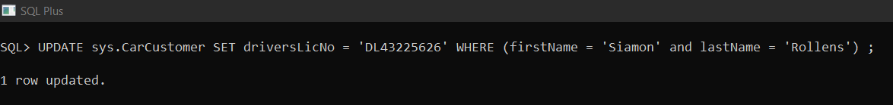

**The User3 has the privilege to Select and Insert on table CuZip.**

**The User4 has the privilege to Select, Update on CarSalesPerson Table.**

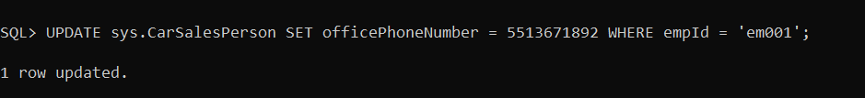

**The User5 has the privilege of Select, Insert, Update on CarModel table.**

**Step 8.4 - Design an audit trail trigger for updates to a sensitive/private item. Then create the audit trail trigger in the database.** Show your work by providing screenshots of creating the trigger in the database.

**Step 8.5 – Design and execute SQL statements to demonstrate that the trigger is working as expected.** To demonstrate that the trigger is working as expected, provide a screenshot of the data before and after the trigger is executed.